**Practical 20: Write a program to update and delete a record from database table.**

**Exercise:**

1. **Develop a program to update name of student from Jack to John.**

import java.sql.*;

public class pract20_ex1

{

    private static final String url = "jdbc:mysql://localhost:3306/msbte";

    private static final String username = "root";

    private static final String pasword = "ksp1303@@##ok";

public static void main(String[] args)

    {try

    {Class.forName("com.mysql.cj.jdbc.Driver");

        Connection c =  DriverManager.getConnection(url, username, pasword);

        Statement s = c.createStatement();

        String q = String.format("UPDATE msbte.student SET Name='%s' WHERE Name='%s' " , "John" , "Jack");

        s.executeUpdate(q);

        System.out.println("Connection successful");

    }

    catch(Exception e)

    {e.printStackTrace();}}}

Before Update Output:

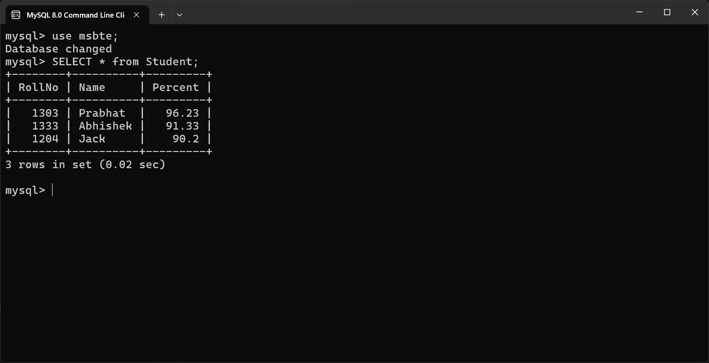

After Update Output:

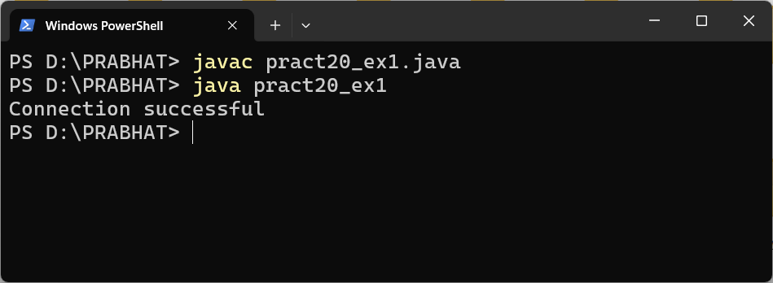

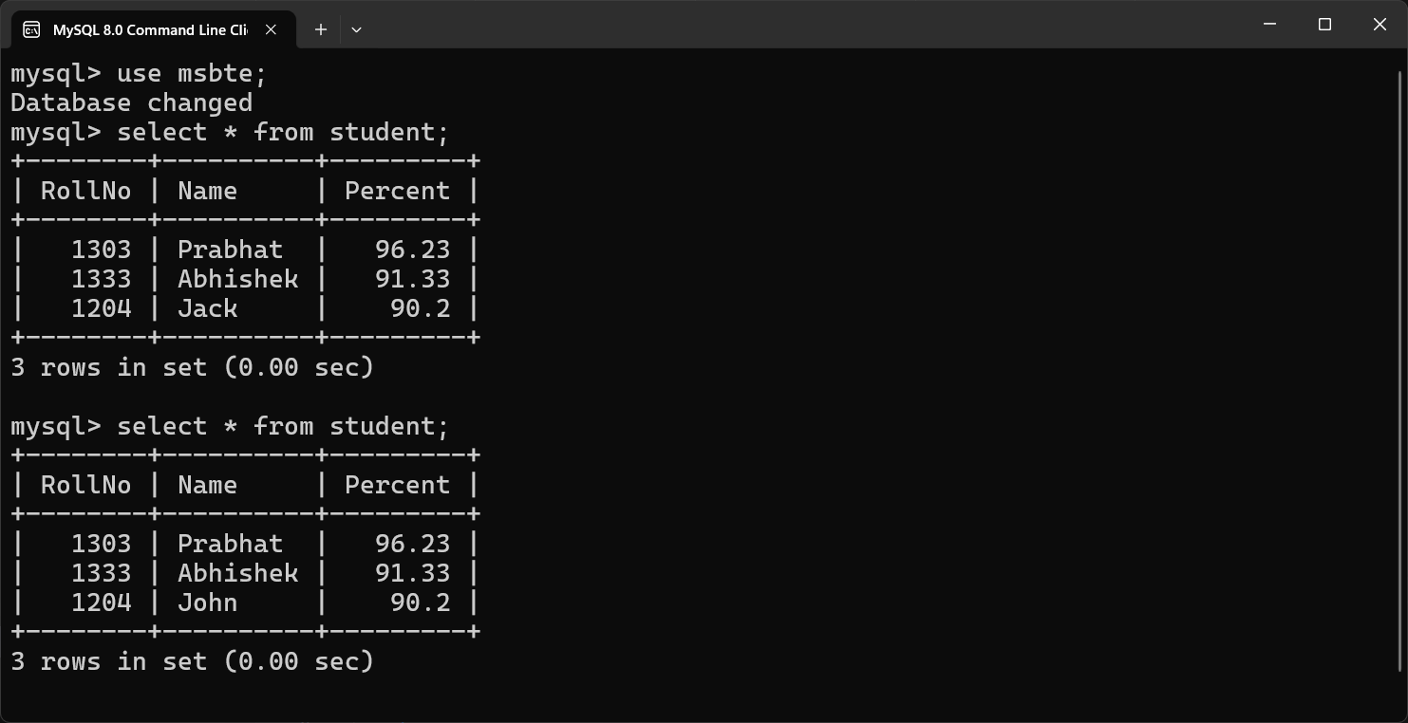

1. **Develop a program to delete all record of a product whose “price is greater than 500” and Id is “P1234”.**

import java.sql.*;

public class pract20_ex2

{private static final String url = "jdbc:mysql://localhost:3306/dbtest";

    private static final String username = "root";

    private static final String pasword = "ksp1303@@##ok";

    public static void main(String[] args)

    {try

        {Class.forName("com.mysql.cj.jdbc.Driver");

        Connection connection = DriverManager.getConnection(url, username, pasword) ;

        Statement statement = connection.createStatement();

        String query = String.format("DELETE FROM dbtest.product WHERE Price=%d AND Id= '%s' " , 500 , "P1234");

        statement.executeUpdate(query);

        System.out.println("Connection successful");

        }catch(Exception e)

        {e.printStackTrace();}}}

**Before Delete:**

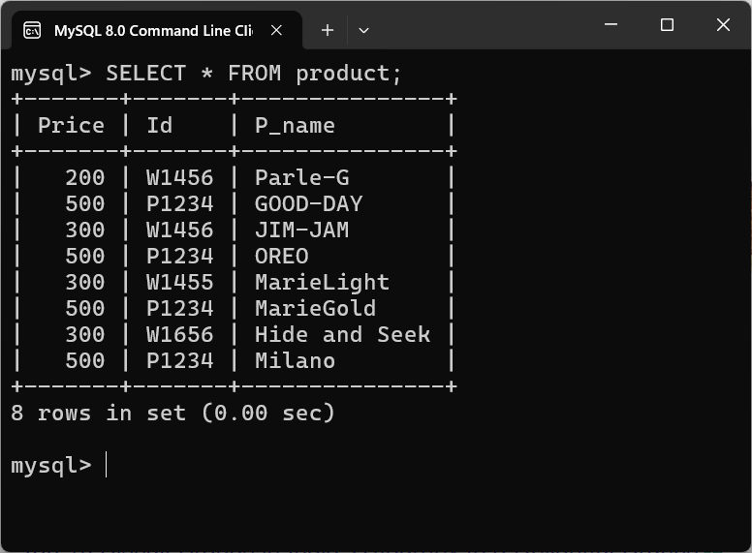

**After Delete Query:**

